Managing the Table for the Activities Main Page

## Content Element

The content element is located in the “Normal” section of the template.

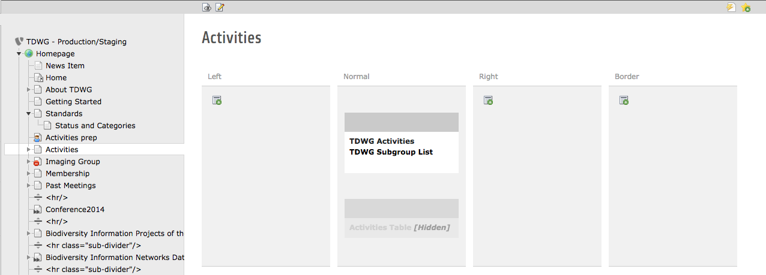

It is a Text element with a hidden header. The purpose of the hidden header is so the element has a title on the template page so you can tell what it is.

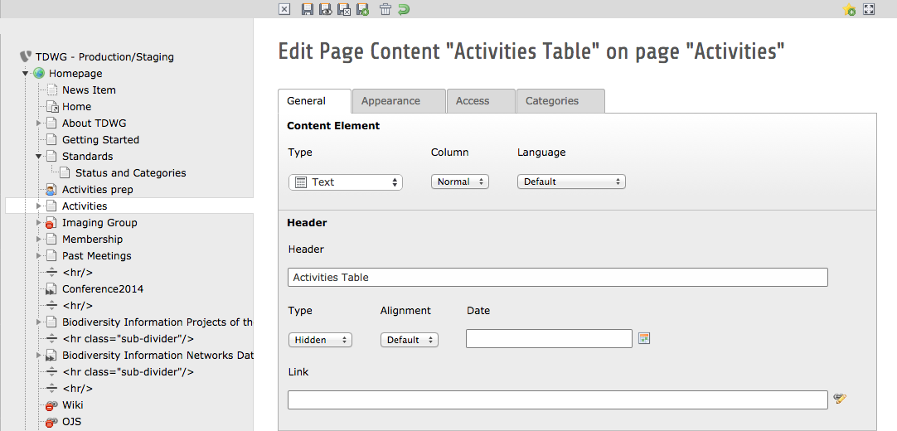

## Creating the Table

The base table has already been created, but instructions are included here in case it needs to be changed in the future.

The table is created in the “Text” section of the content element configuration.

1. Click the “Insert Table” button in the toolbar.

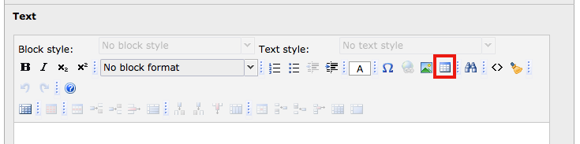

1. Set the table to have 5 rows and 6 columns. Make sure the “Header Cells” option is set to “Header cells on top.” Choose “Stadard container for table” in the Style drop down. Click OK.

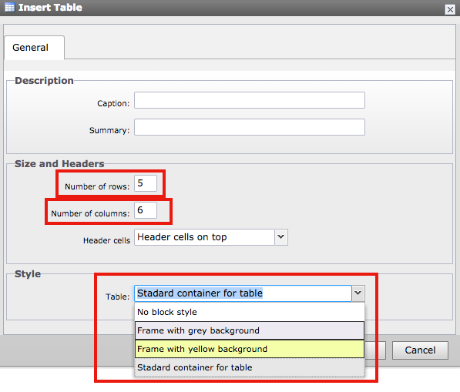

1. Type in your headers: “Title”, “Type”, “Status”, and “Links”. Leave a blank column after “Title” and “Links”.

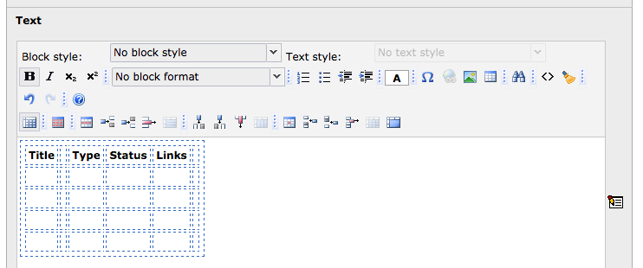

1. Since the “Title” and “Links” column each require two separate columns under the heading, you now need to merge the header cells for those items.
   1. Place your cursor in the “Title” cell and click the “Merge” button in the toolbar

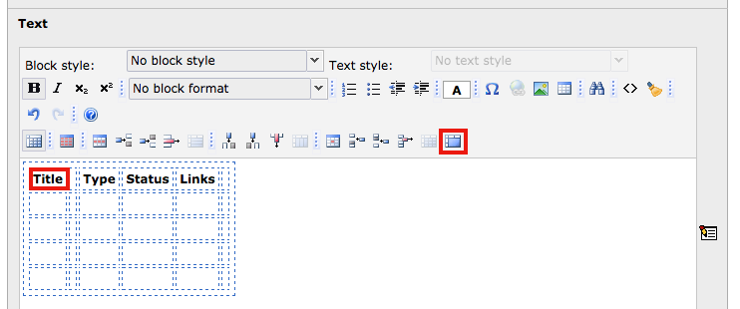

* 1. When prompted, set the cell merge to 2 and click OK. On the next prompt, set the row merge to 1 and click OK.

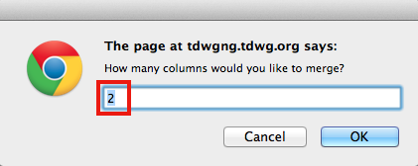

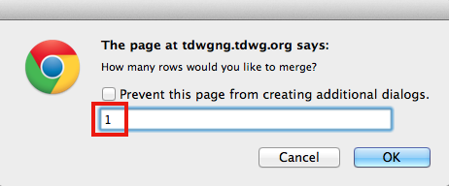

* 1. Repeat steps a & b for the “Links” heading

1. To set the header style, highlight all the text in the header row. It must **all** be highlighted. This cannot be done cell-by-cell. “Choose Header in table” from the Block Style drop down list.

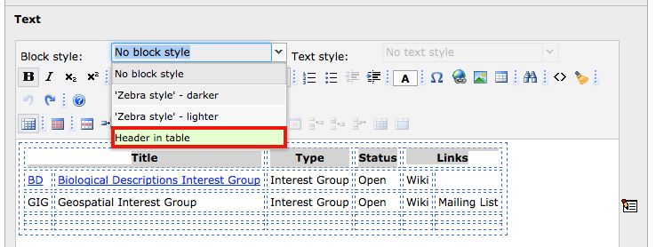

1. Type in your details for each activity
   1. To create links, highlight the text you want to link, and click the “Insert Link” button in the toolbar

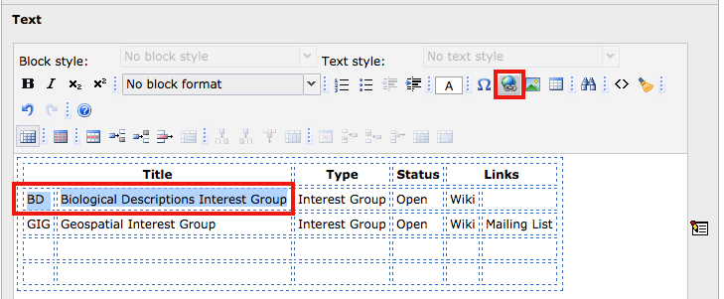

* 1. In the Insert Link dialog, choose the “Page” option if that was not the default. Open the Page Tree until you locate the page you want to link to, and click on the page. This will create the link. The default is for the links to be created in the same window. To have them open in a new window, change the selection in the “Style” drop down.
  2. As you make entries to the table, tabbing at the end of the final row will create a new row

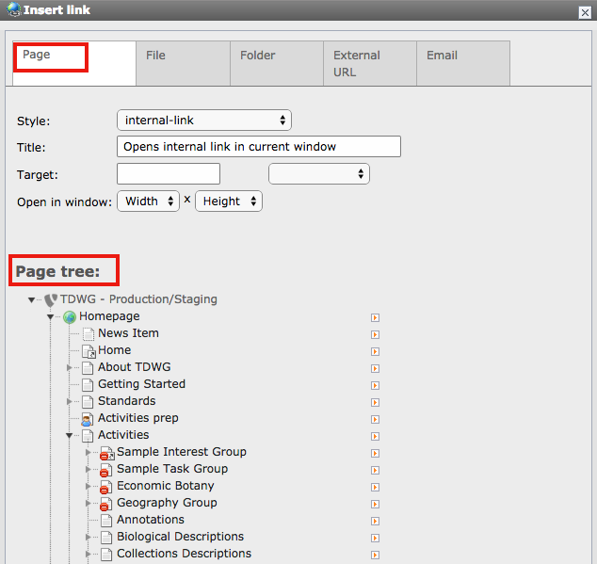

1. To add the dark or light grey background color to a row, highlight all the cells in the row. Choose “Zebra style - darker” or “Zebra style - lighter” from the Block Style drop down list.

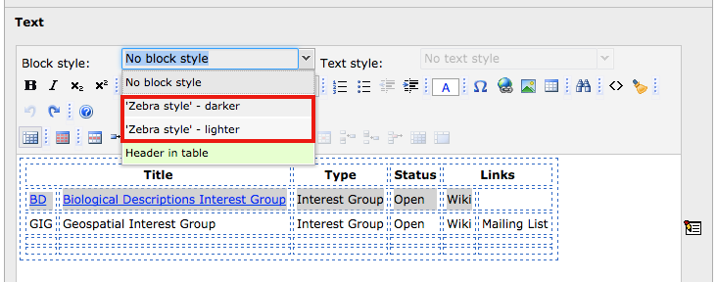

1. Save your changes